20.32: a) The final temperature, found using the methods of Chapter 17, is

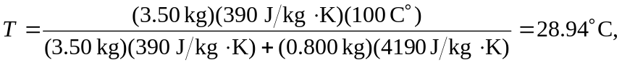

or 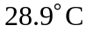 to three figures. b) Using the result of Example 20.10, the total change in entropy is (making the conversion to Kelvin temperature)

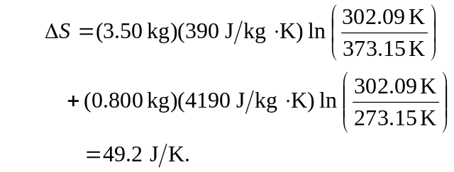

(This result was obtained by keeping even more figures in the intermediate calculation. Rounding the Kelvin temperature to the nearest 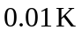 gives the same result.

